Database Setup

-- DROP DATABASE EmpDept;

CREATE DATABASE EmpDept;
USE EmpDept;

CREATE TABLE Department (
DepartmentID INT PRIMARY KEY AUTO_INCREMENT,
DepartmentName VARCHAR(50) NOT NULL
);

CREATE TABLE Employee (
EmpID INT PRIMARY KEY,
Name VARCHAR(100) NOT NULL,
DepartmentID INT,
Salary DECIMAL(10, 2),
JoiningDate DATE,
FOREIGN KEY (DepartmentID) REFERENCES Department(DepartmentID)
);

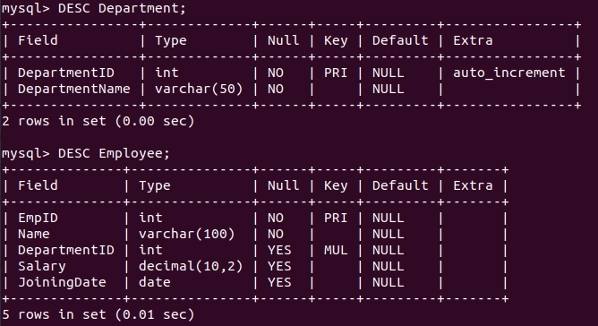

Inserting Data

INSERT INTO Department (DepartmentName) VALUES
('HR'),
('Finance'),
('Engineering'),
('Marketing');

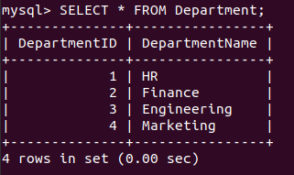

INSERT INTO Employee (EmpID, Name, DepartmentID, Salary, JoiningDate) VALUES
(101, 'Alice', 1, 50000, '2020-06-15'),
(102, 'Bob', 2, 70000, '2018-03-20'),
(103, 'Charlie', 3, 120000, '2017-11-10'),
(104, 'David', 4, 45000, '2021-09-25'),
(105, 'Eve', 3, 110000, '2019-07-30'),
(106, 'Frank', 2, 80000, '2020-01-12'),
(107, 'Grace', 1, 55000, '2022-04-05');

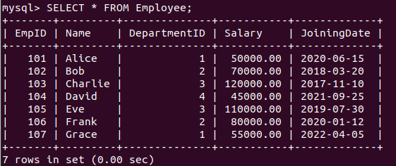

-- View 1
CREATE VIEW AverageSalaryByDepartment AS
SELECT
d.DepartmentName,
AVG(e.Salary) AS AverageSalary
FROM
Department d
JOIN
Employee e ON d.DepartmentID = e.DepartmentID
GROUP BY
d.DepartmentName;
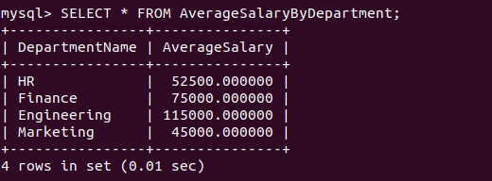

-- View 2
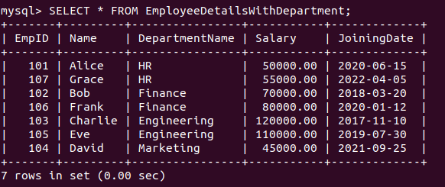
CREATE VIEW EmployeeDetailsWithDepartment AS
SELECT
e.EmpID,
e.Name,
d.DepartmentName,
e.Salary,
e.JoiningDate
FROM
Employee e
JOIN
Department d ON e.DepartmentID = d.DepartmentID;

-- View 3
CREATE VIEW HighestPaidEmployeePerDepartment AS
SELECT
d.DepartmentName,
e.Name,
e.Salary
FROM
Employee e
JOIN
Department d ON e.DepartmentID = d.DepartmentID
WHERE
(e.DepartmentID, e.Salary) IN (
SELECT
DepartmentID,
MAX(Salary)
FROM
Employee
GROUP BY
DepartmentID
);
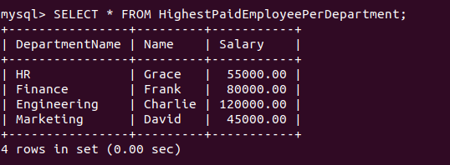
-- View 4
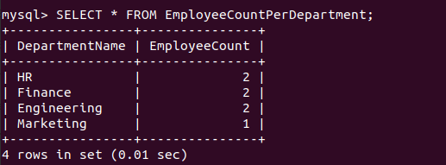
CREATE VIEW EmployeeCountPerDepartment AS
SELECT
d.DepartmentName,
COUNT(e.EmpID) AS EmployeeCount
FROM
Department d
LEFT JOIN
Employee e ON d.DepartmentID = e.DepartmentID
GROUP BY
d.DepartmentName;
Queries

-- View 1 Queries
1)
SELECT DepartmentName, AverageSalary
FROM AverageSalaryByDepartment
WHERE AverageSalary > (
SELECT MAX(AverageSalary) * 0.5
FROM AverageSalaryByDepartment
);
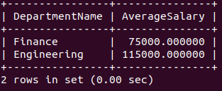

2)
SELECT DepartmentName, AverageSalary
FROM AverageSalaryByDepartment
ORDER BY AverageSalary DESC
LIMIT 1 OFFSET 1;

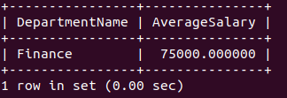

3)
SELECT DepartmentName, AverageSalary
FROM AverageSalaryByDepartment
WHERE AverageSalary > (
SELECT AVG(Salary)
FROM Employee
);

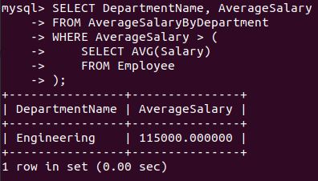

-- View 2 Queries
1)
SELECT Name, DepartmentName, Salary
FROM EmployeeDetailsWithDepartment
ORDER BY Salary DESC
LIMIT 3;

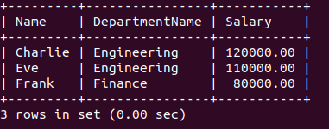

2)
SELECT Name, DepartmentName, JoiningDate
FROM EmployeeDetailsWithDepartment
WHERE JoiningDate > '2020-12-31'
AND DepartmentName IN ('Engineering', 'Finance');

3)
SELECT SUM(Salary) AS TotalSalary
FROM EmployeeDetailsWithDepartment
WHERE DepartmentName = 'Marketing';

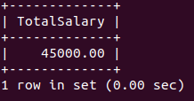

-- View 3 Queries
1)
SELECT Name, DepartmentName, Salary
FROM HighestPaidEmployeePerDepartment
ORDER BY Salary DESC
LIMIT 1;

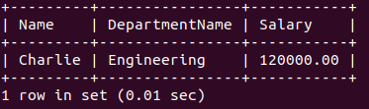

2)
SELECT Name, DepartmentName, Salary
FROM EmployeeDetailsWithDepartment
WHERE Salary > (
SELECT Salary
FROM HighestPaidEmployeePerDepartment
WHERE DepartmentName = 'HR'
);
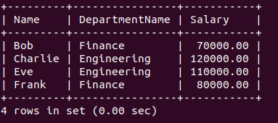

3)
SELECT Name, DepartmentName, Salary
FROM HighestPaidEmployeePerDepartment
WHERE Salary < 100000
ORDER BY Salary DESC
LIMIT 1;

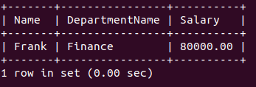

-- View 4 Queries
1)
SELECT DepartmentName, EmployeeCount
FROM EmployeeCountPerDepartment
WHERE EmployeeCount > (
SELECT AVG(EmployeeCount)
FROM EmployeeCountPerDepartment
);

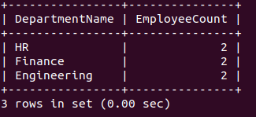

2)
SELECT DepartmentName, EmployeeCount
FROM EmployeeCountPerDepartment
ORDER BY EmployeeCount ASC
LIMIT 1;

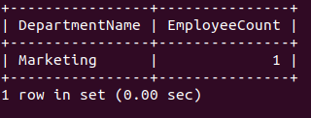

3)
SELECT DepartmentName, EmployeeCount
FROM EmployeeCountPerDepartment
WHERE EmployeeCount BETWEEN 2 AND 5;

